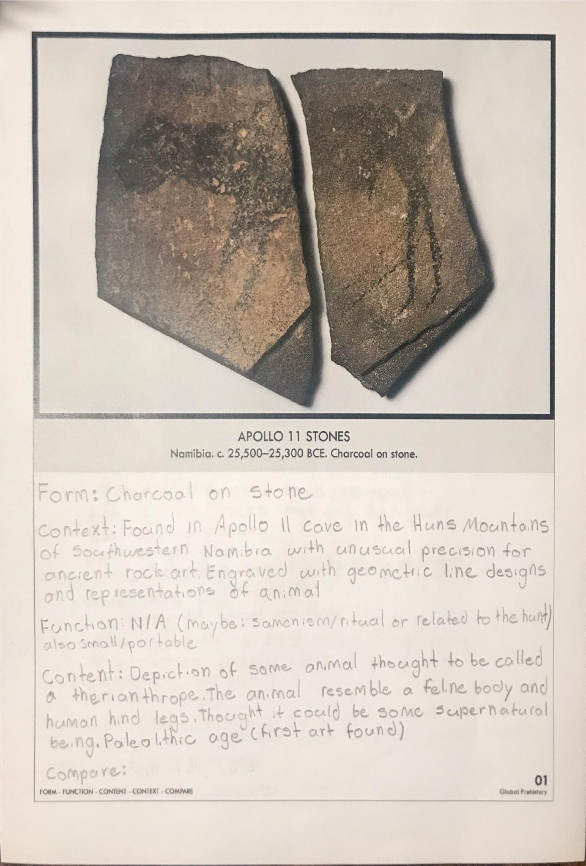

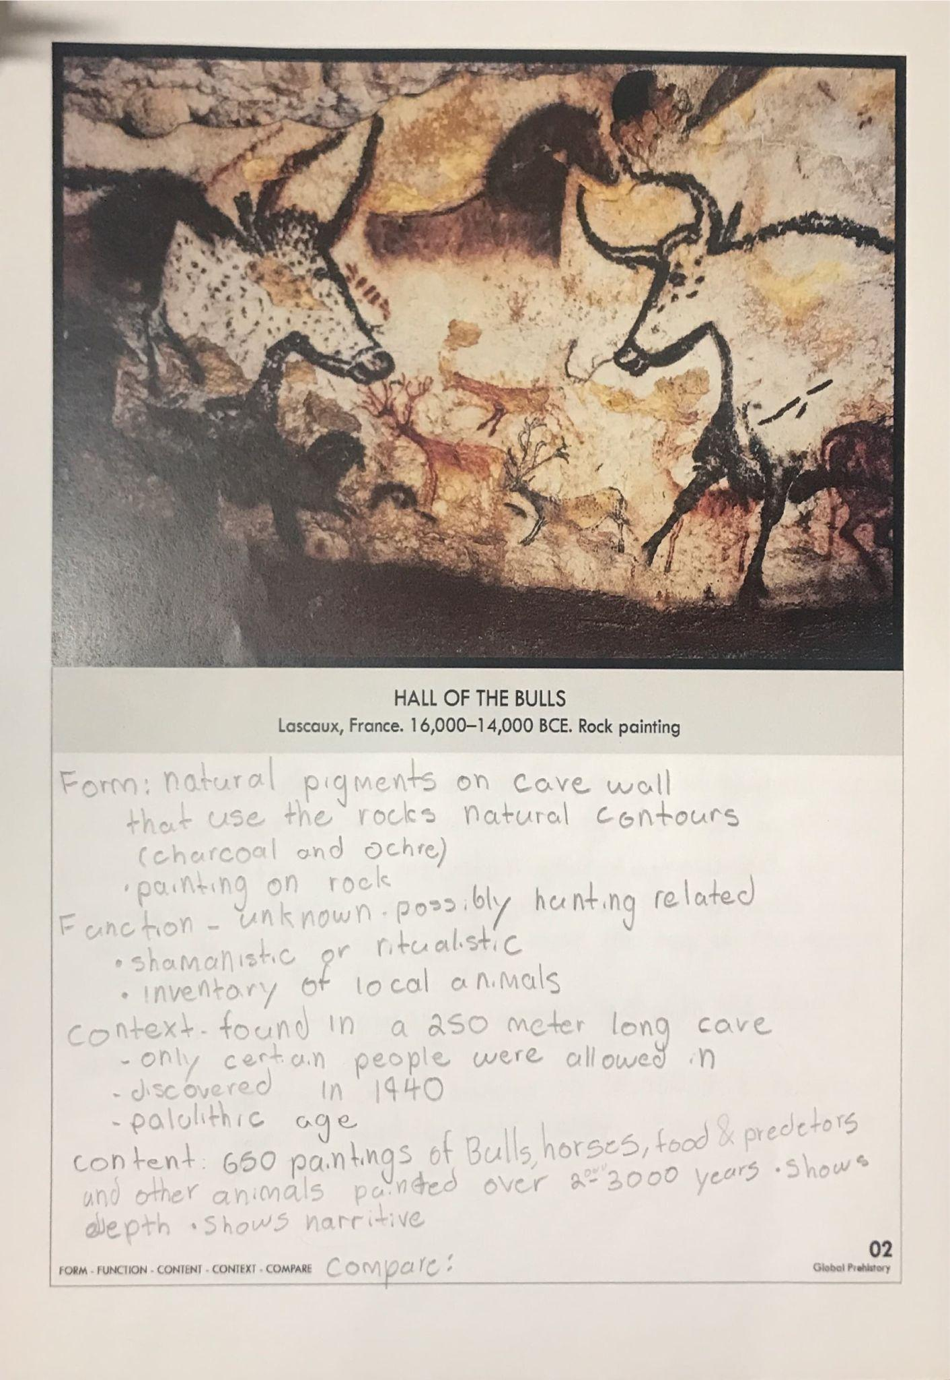

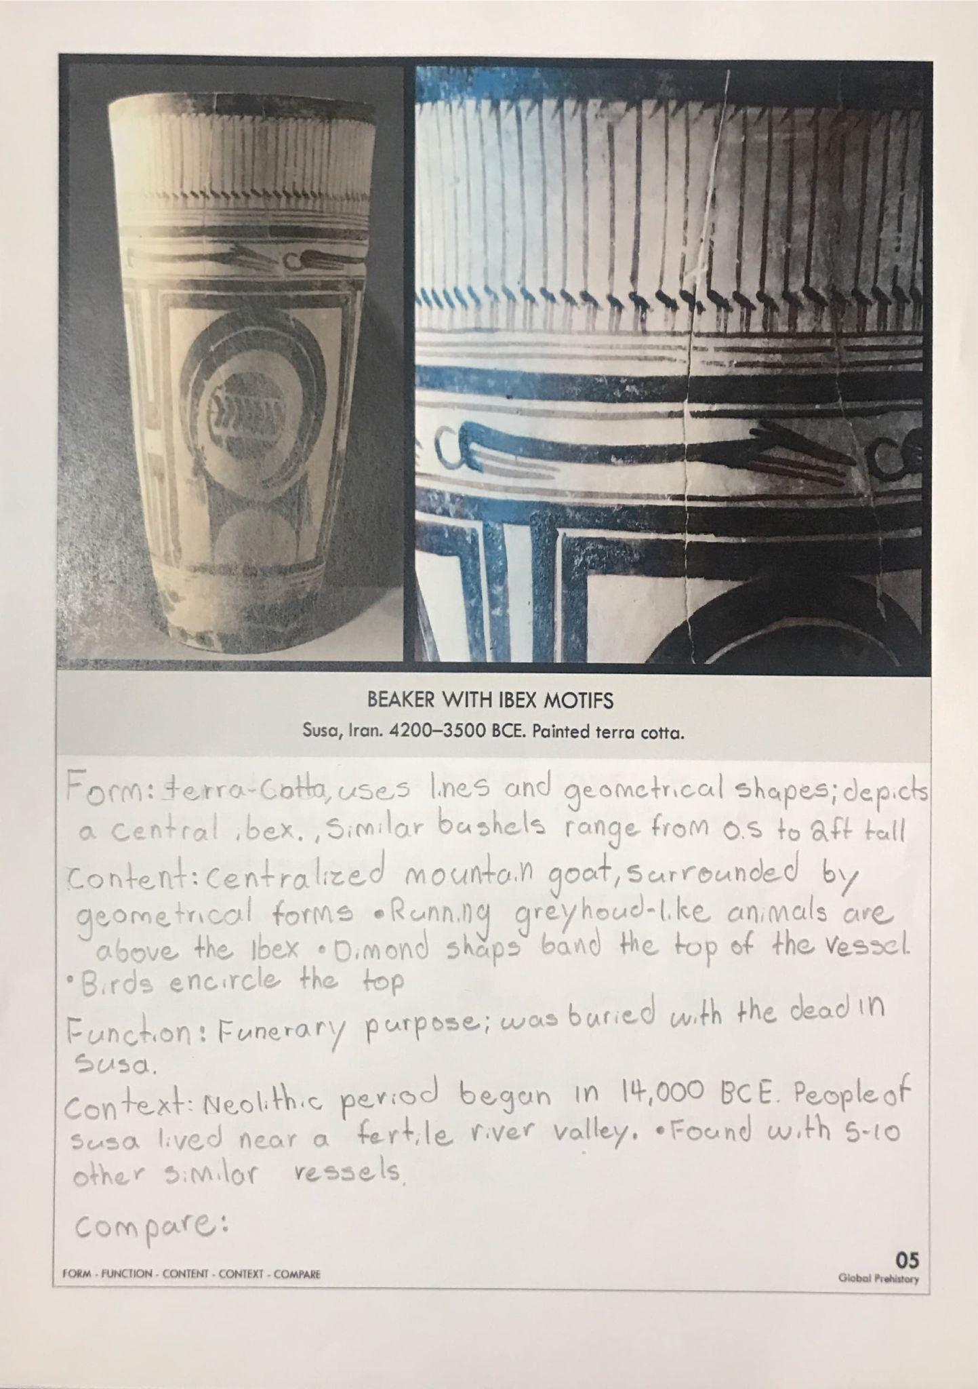

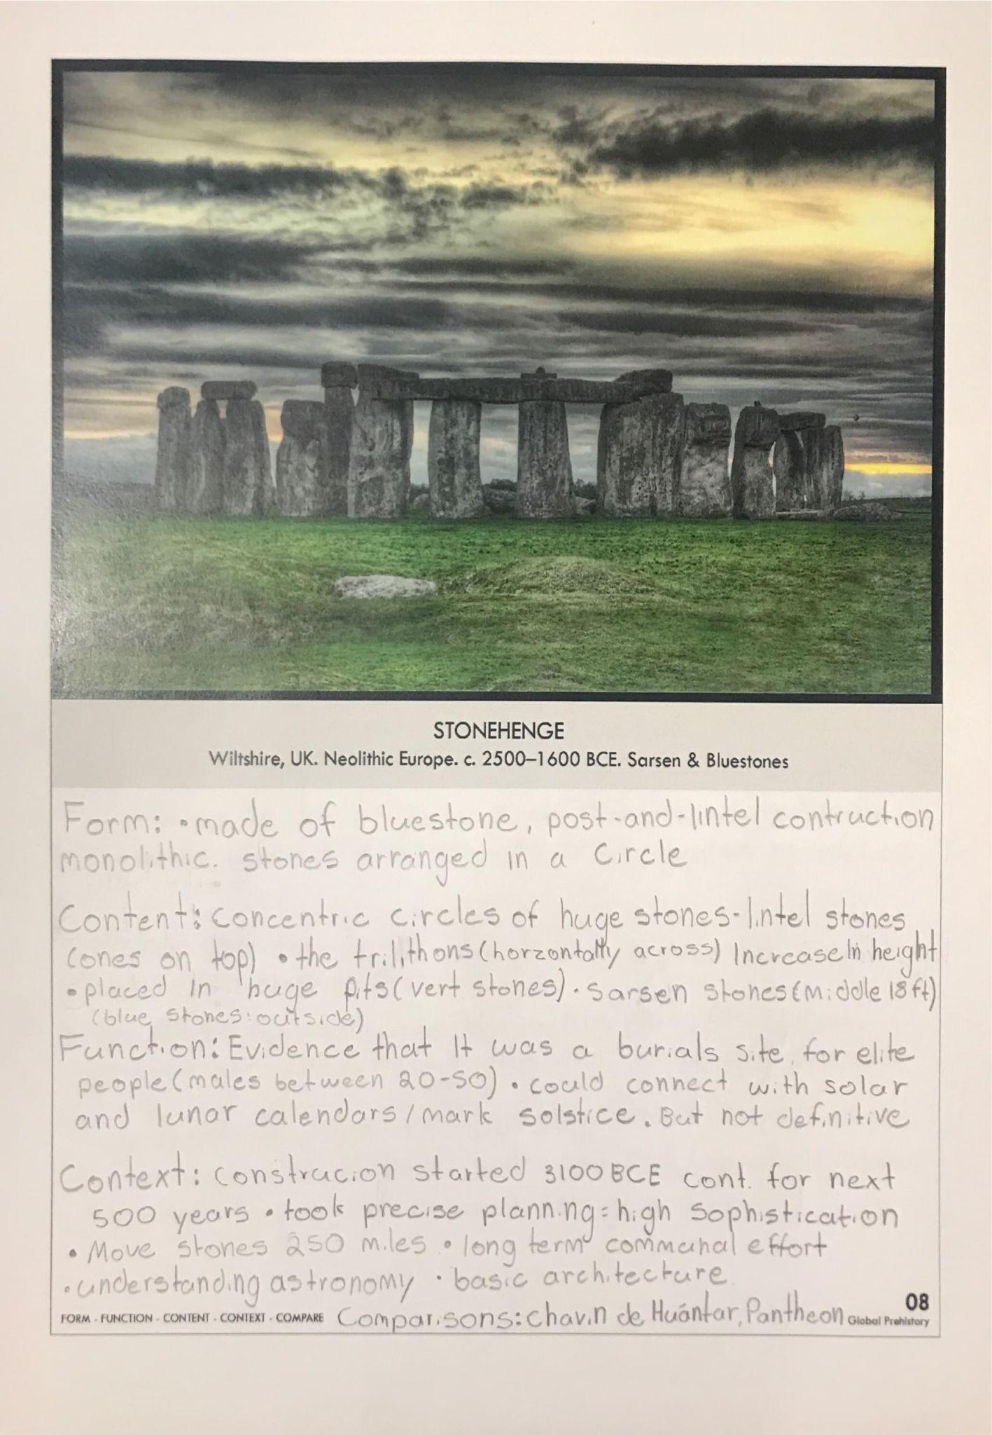

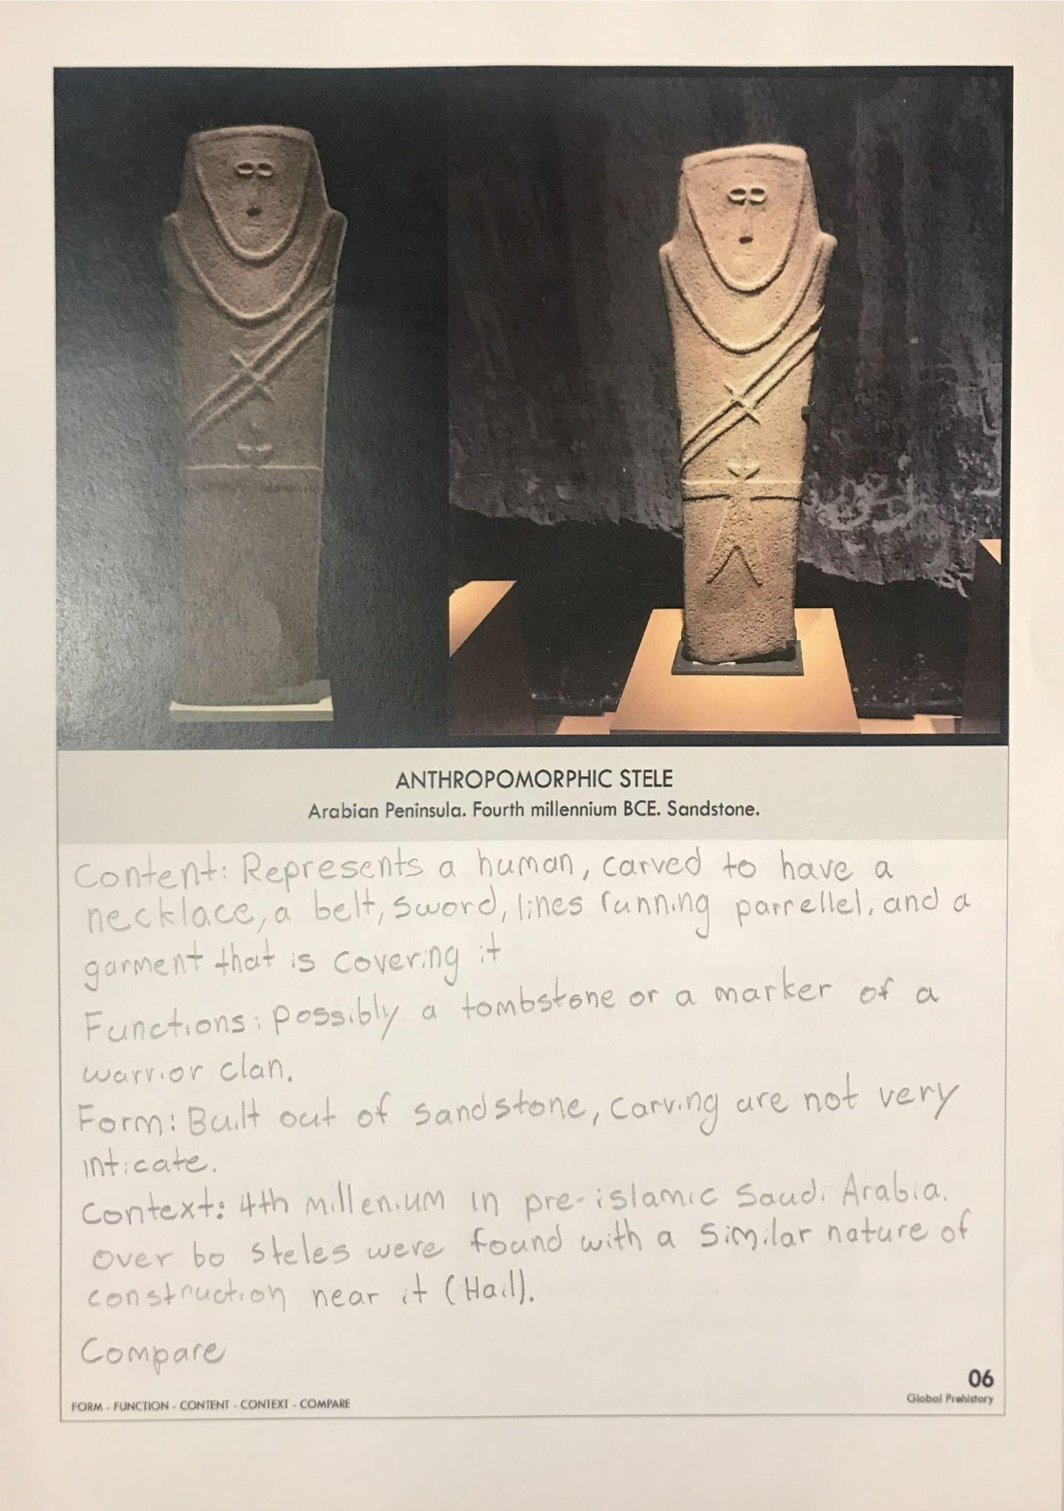

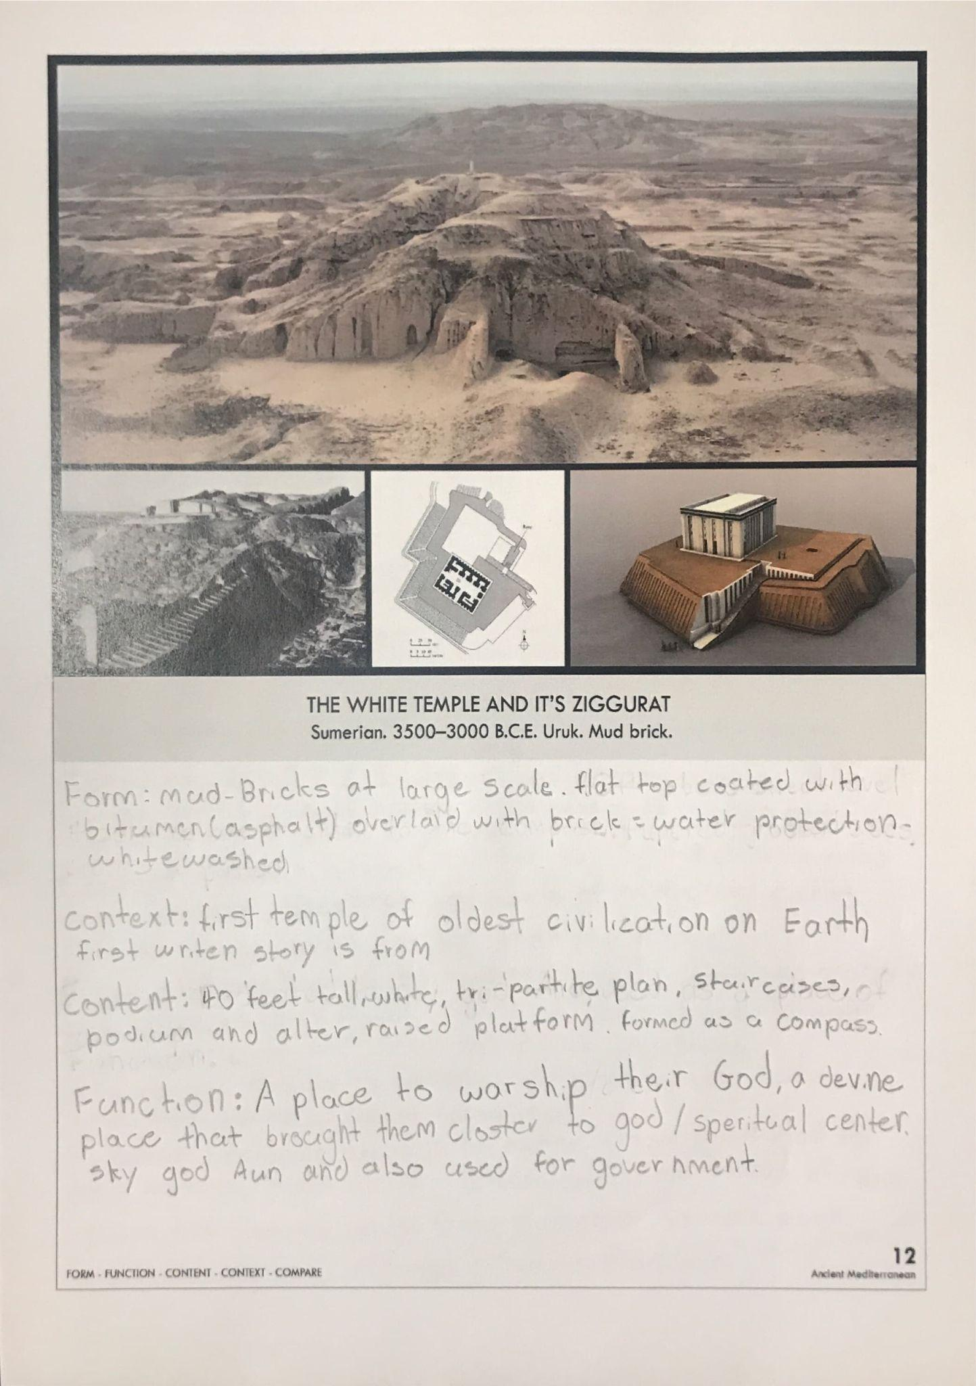

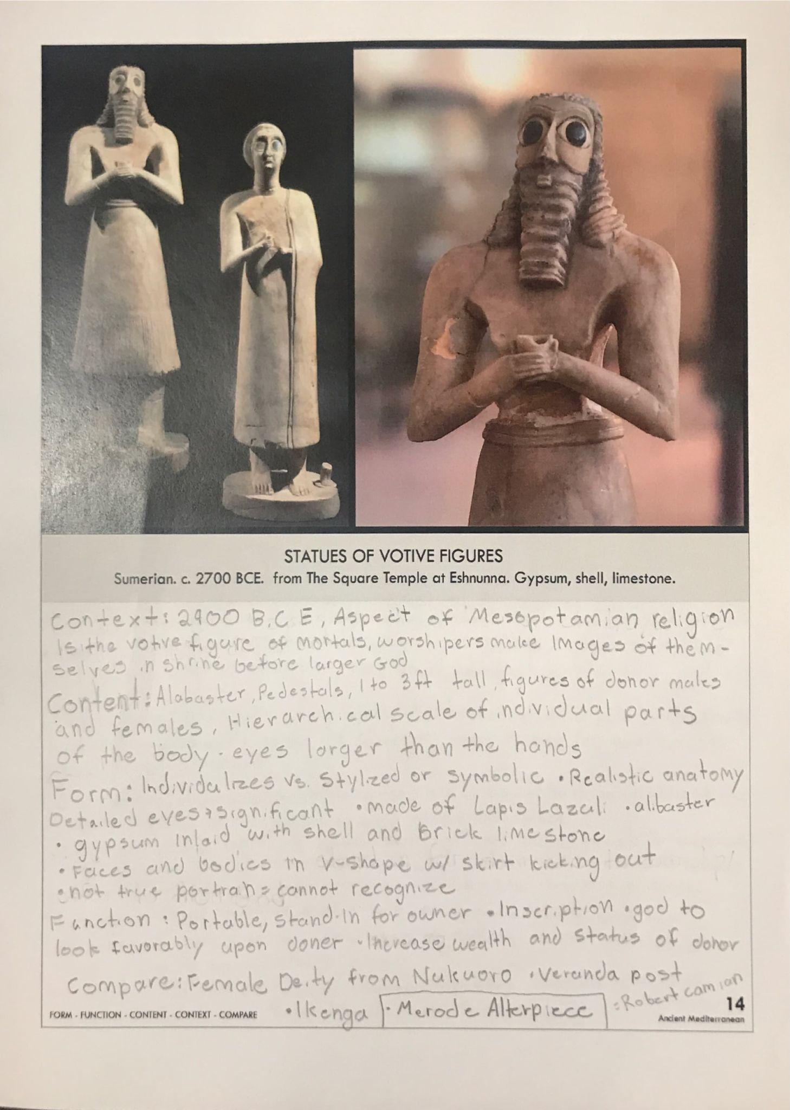

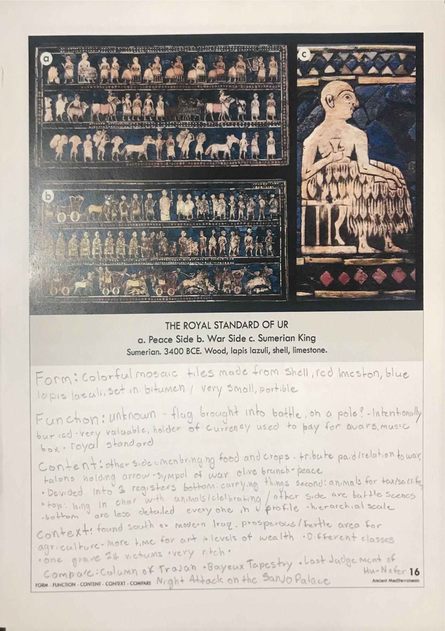

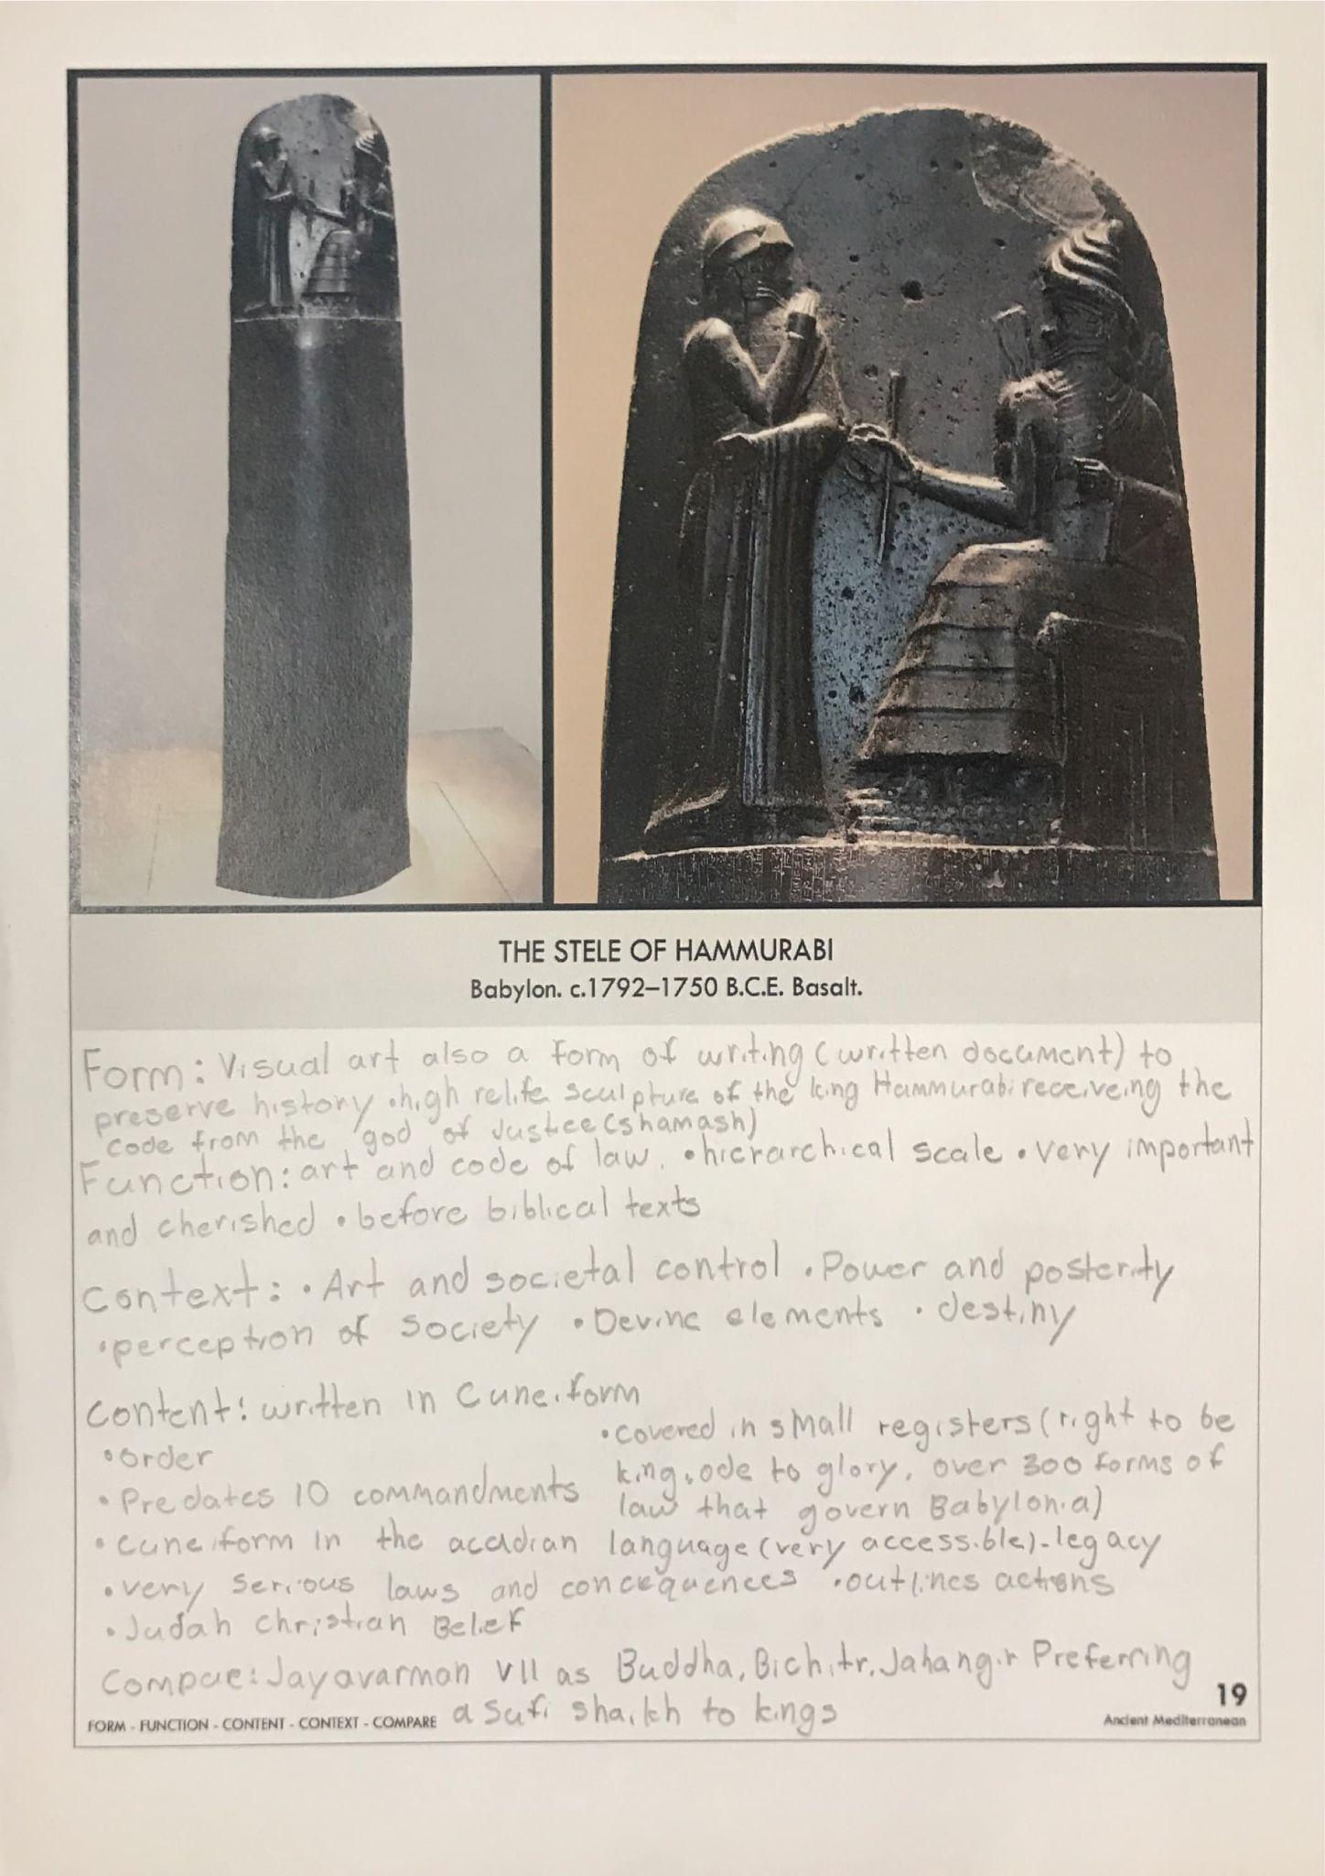

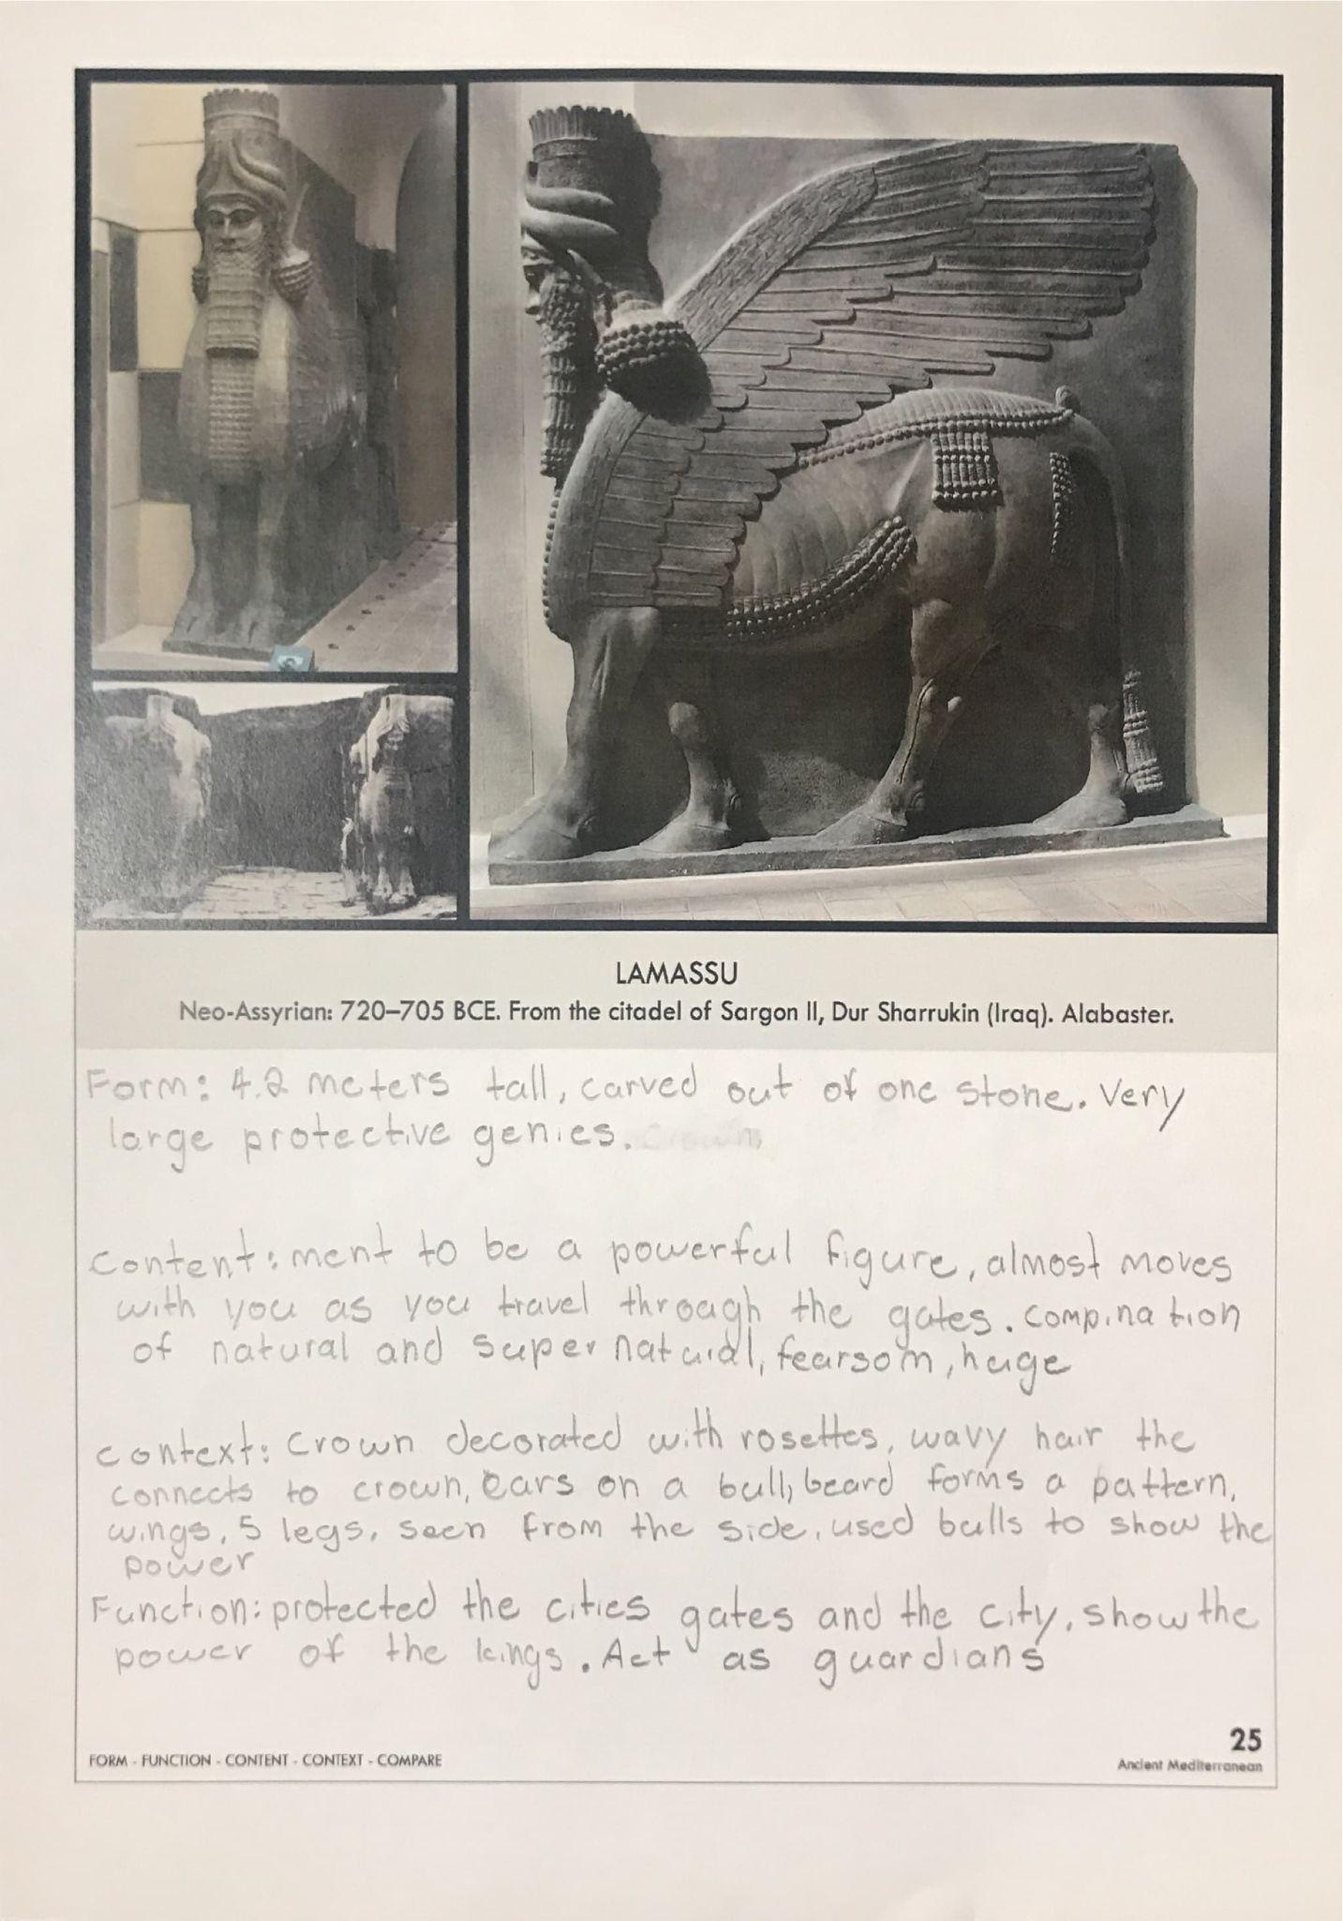

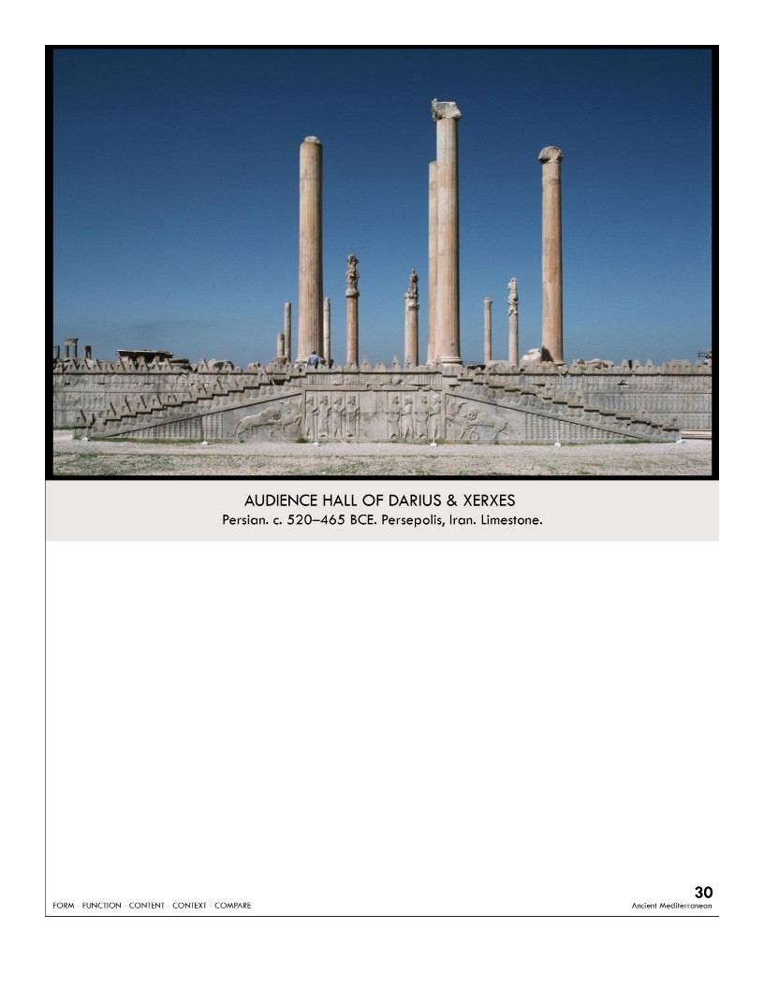

| **Form**:   * Carved primarily of Limestone * The carvings on the walls were bas-relief * Display the importance and authority of the King   **Function:**   * Represent the expansive nature of the Persian Empire and the Emperor's power * Ceremonial Hall * Served as the center of the Persian Empire's capital   **Content**:  Walls were carved with illustrations of hundreds of figures bringing offerings to the king from all the states conquered by the Persian Empire. Bulls, Eagles and Lions are all symbols of royalty. Built on a plateau, stairway leading up to the raised platform, columns are 67 feet/24 meters, and there are 36 of them. Made of mud brick with carved stone faces and a wooden roof.  **Context**:  Built by rulers Darius 1 And Xerxes as the ceremonial and administrative center of the empire, Destroyed by Alexander the great. Built by many different cultures. represented in the bas-relief carvings displaying all the ethnic groups the Persians conquered.  **Compare:**  Palace of Versailles /gardens,  **30**  Ancient Mesopotamia |
| --- |

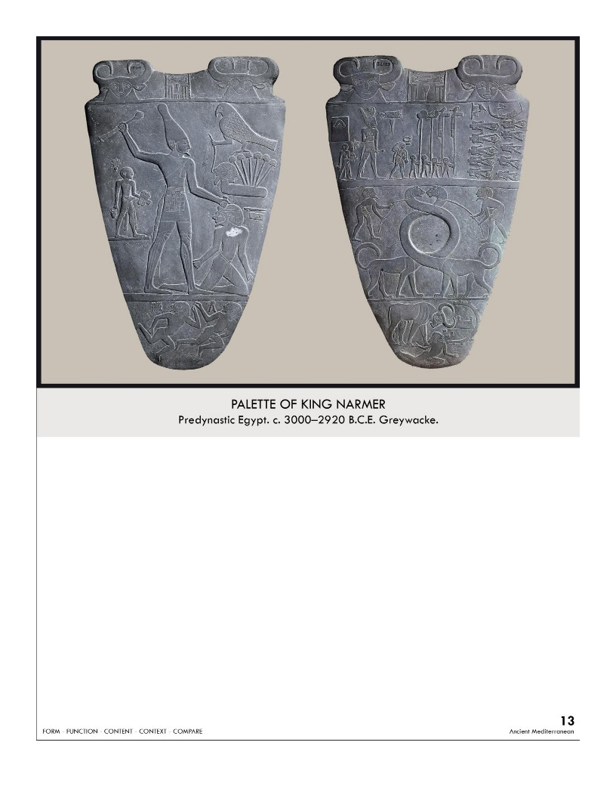

| **Form:**  Slate- rock. Height 25 ft. it’s a small flat bas-relief sculpture  **Function:**  Unknown: maybe decorative makeup pallet used by the pharaoh or aristocrats (rich people)  **Content:**  **Front**: Full of stories told in registers/ lines. Depicts hierarchical scale(the king is the biggest) **Back**: show Narmor attacking a lower Egyptian warrior(defeating) the top are some of the earliest hieroglyphics in Egypt. Nar-Mer. Horus a falcon headed god ( concurring lower Egypt)  **Context:**  unification of upper and lower Egypt by the first pharaoh, tells stories pictorially.  Oldest narrative art in Egypt  both sides the lowest register features the dead bodies of defeated enemies, again demonstrating Egyptian strength  **Compare:**  Royal Standard of Ur (Sumer)  **13**  Ancient Mediterranean |
| --- |

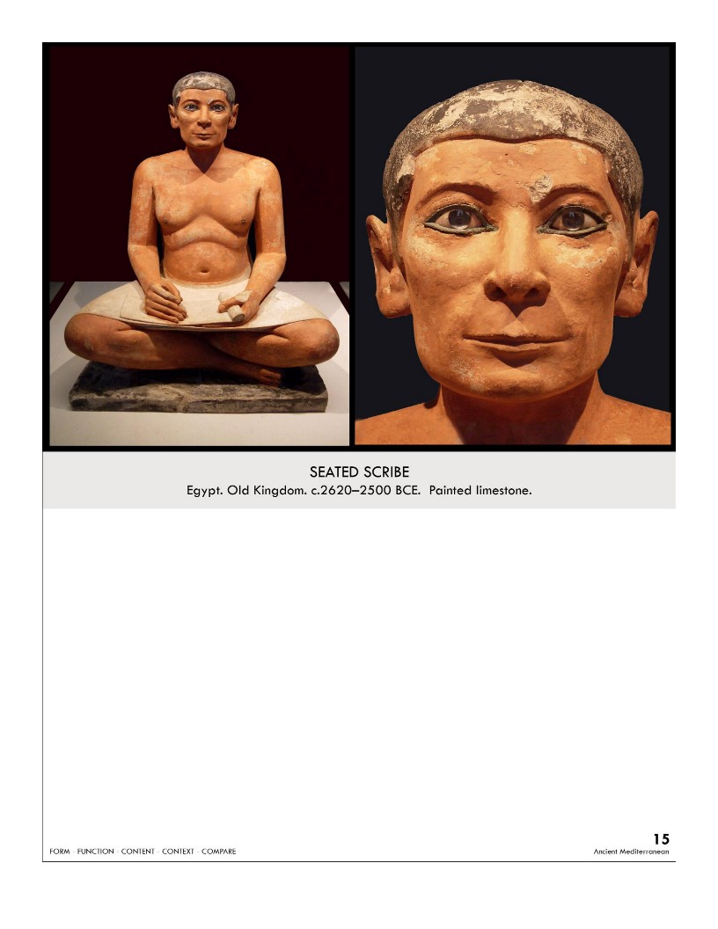

| **Form:** Painted limestone 1 foot 9 inches. Unique that the figure is seated as opposed to upright and statuary  **Function:** made to sit in the tomb and write forever. Commemorate and revere the scribe himself and his importance in preserving Egyptian history. Serves a funerary purpose to help the scribe transcend into the afterlife.  **Content:** very realistic features. **Holds a papyrus scroll**   1. Midriff fat shows his wealth and importance 2. His tranquil face symbolizes wisdom. 3. depicted at work   **Context:**   1. scribe from the Necropolis at Saqqara, Egypt. 2. Scribes were revered for their literacy and writing abilities, which were not ubiquitous at the time.   **Compare:**  **15**  Ancient Mediterranean |
| --- |

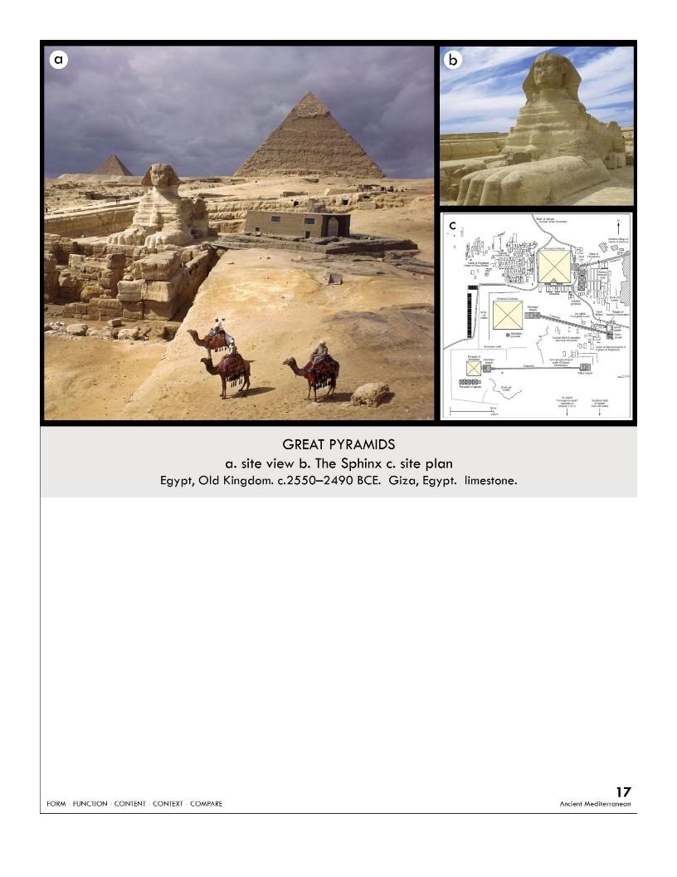

| **Form:**  The largest Khufu has about 2.3 million stone blocks that range from 2.5 to 15 tones a piece  Most preserving equally sided limestone build pyramids, internal passages and chambers pharaoh in the middle. Part of a complex, sphynx as a guardian figure  **Function:**  Tombs for the pharaohs/afterlife projection champers  **Content:**  three major pyramids for three rulers over three generations and many other smaller cemeteries and temples.  **Context:**  Competed by 20000-30000 workers over a 75-year period. Proud to be building them, fed well, permanent employees of the pharaoh  We still don't know how these were built.  Pharaohs were kings, but also divine. tallest things for over 4000 years  **Compare:**  **17**  Ancient Mediterranean |
| --- |

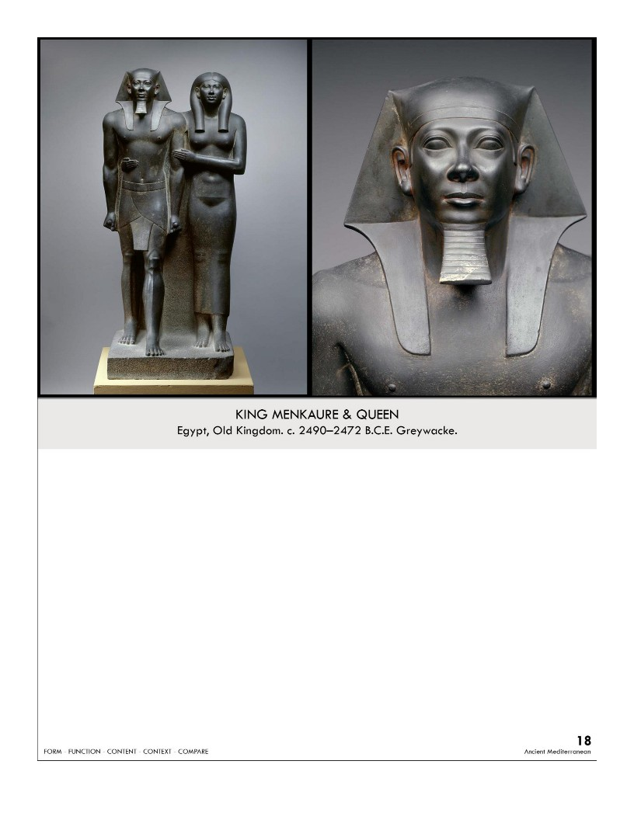

| **Form:** 54.5 height made of slate, freestanding, life size. Both extend one foot forward & maintain an erect posture  **Function:**  Religious Art for the pharaoh, power of religion( portrait in a way)   * Communicates the divinity & absolute power of the ruler * Likely emerged from a niche in a memorial structure   **Content:** Menkaure and his wife, idealized features, not very realistic. Slight hierarchy of scale, but Menkaure’s wife is almost his height. Commitment to carving shows devotion to the ruler Tough stone lasts/doesn’t erode  **Context:** shows the status of Egyptian women ( similar to the same level). Strongly defined social/political structure (Pharaoh = absolute ruler)  **Compare:**  **18**  Ancient Mediterranean |
| --- |

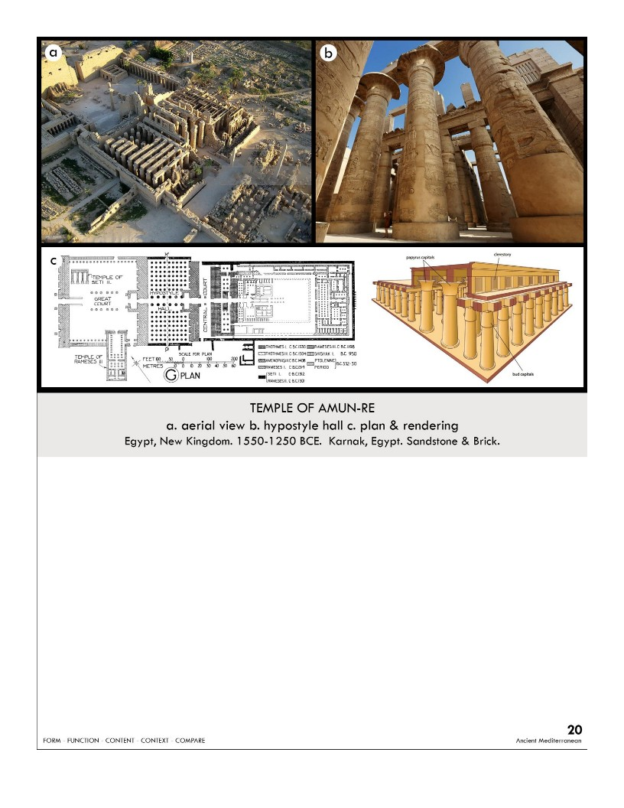

| **Form:**  247 acres surrounded by a 39 foot high wall. Made out of limestone. Clerestory lighting, meaning it was natural and coming from openings above  **Function:**  Dedicated temple to the sun god Amen-Re ( the principle religious center of Eygpt of the time)  **Content:**  Sacred lake of the egyptian/ creation myth temple. Symmetrically axial plan, massive entrance pylon gateways  A peristyle courtyard  Hypostyle hall( forest of columns holding up ceiling) 66-foot high  House of the cult statue  clerestory lighting, meaning it was natural and coming from openings above  **Context:**  from the new kingdom of Egypt. Build over a 200 year period by new kingdom pharaohs( many different pharaohs)  **Compare:**  **20**  Ancient Mediterranean |
| --- |

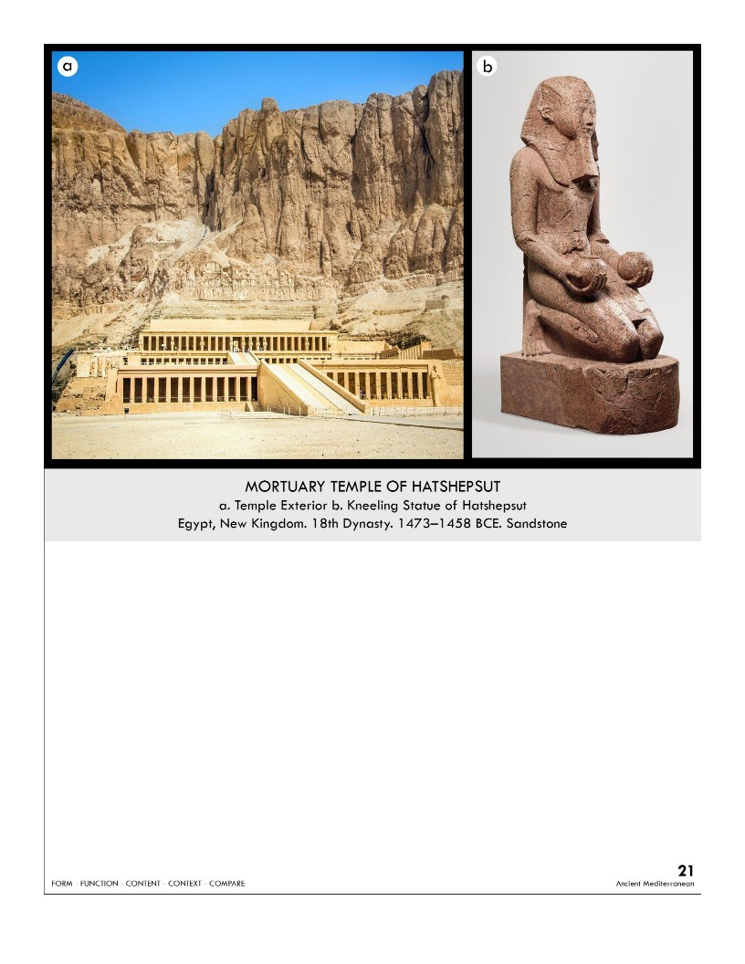

| **Form:**  The Mortuary Temple of Hatshepsut is cut into the stone of the cliff-side. Kneeling Statue is made from granite, which is very durable  **Function:**  funerary temple which shines to Amen, Hathor and Anubis as well as to the 1st known queen in history HAtshepsut and her father. was a place for people to go and appreciate her power by looking at all of the different statues of her  **Content:**  The axial-planned temple rises from the valley floor in three column-lined terraces connected by two ramps and contains over 2000 stones. Kneeling Statue depicts Queen Hatshepsut in a kneeling position. she was one of the only, and most powerful, female pharaohs  **Context:**  First female pharaoh built the temple. Hatshepsut was a female, but many aspects were kept the same--she was still depicted in the idealized form for her statue  **Compare:**  **21**  Ancient Mediterranean |
| --- |

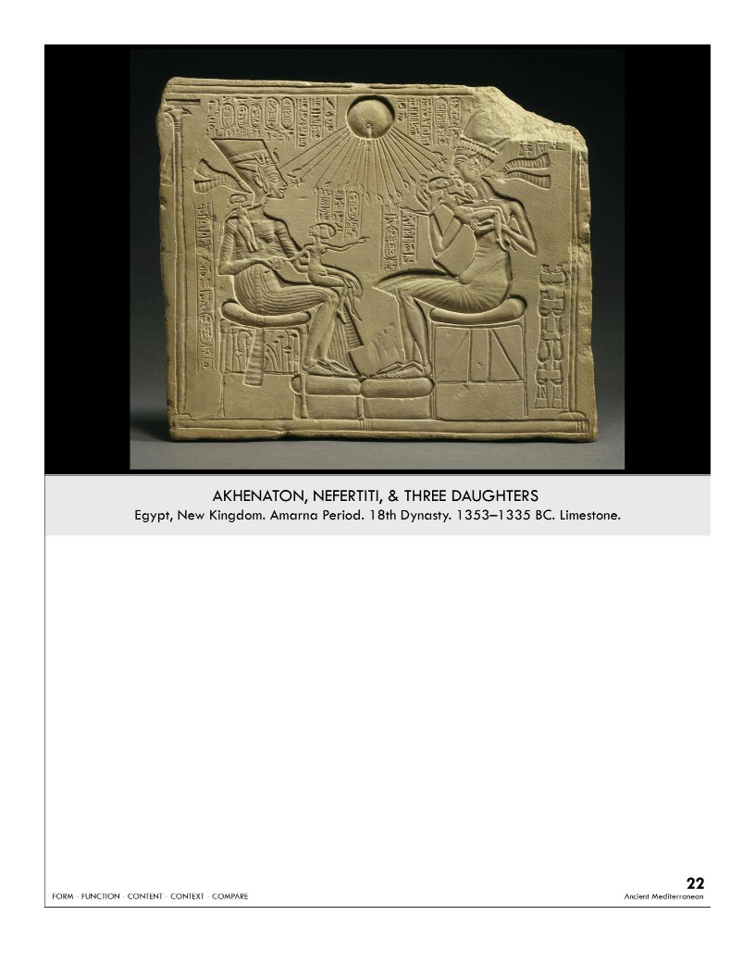

| **Form:**  Bas-reliefs carving, Limestone  32.5 cm high  **Function:**  Meant to be a house altar.  the iconography of Aten and the depiction of the royal family of Akhenaten was propagated to encourage people to embrace the new monotheistic religion  **Content:**  Depicts King Akhenaten, his wife Nefertiti, seated on thrones and holding three of their daughters on their laps in a familial moment  Iconography: monotheistic god Aten represented by the sun disc in the center  **Context:**   * Egyptian art and culture generally experienced little change; the Amarna period is an exception * pharaoh Akhenaten changed state religion from worship of god Amun to monotheistic worship of a new, sun god, Aten * Pharaoh and his wife, Nefertiti, were made to be the only earthly representatives of this new god   **Compare**  **22**  Ancient Mediterranean |
| --- |

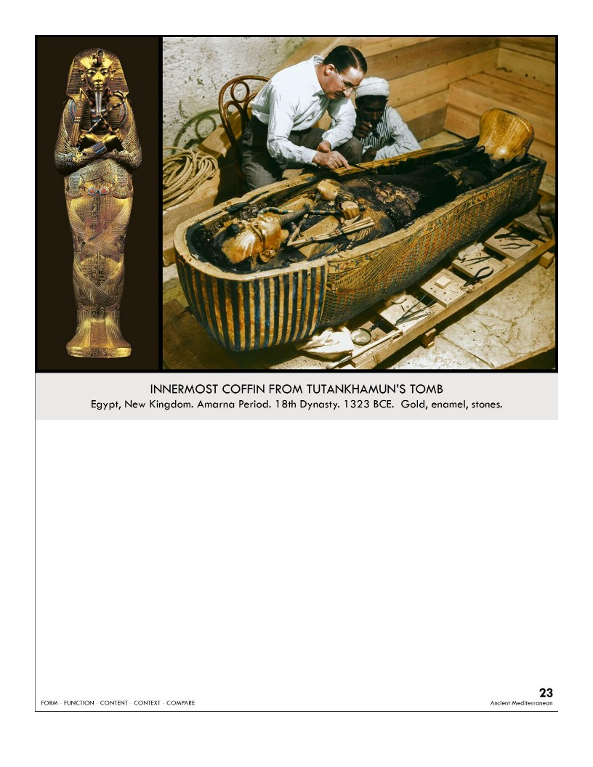

| **Form:**  The innermost tomb was inlaid with gold- 6ft 7in long  three coffins for the kings’ body  **Function:**  sarcophagus was meant to preserve and protect the pharaoh in the afterlife  **Content:**  hold a crook and a flail from - show right as king (god osiris )   * The death mask originally rested on shoulders of the mummy inside the pure gold coffin * pharaoh = god like * The gods were thought to have skin of gold, bones of silver, and hair of lapis lazuli * king is shown here in his divine form in the afterlife   **Context:**  Found at the end of the Amarna period, boy king tutankhamun in the tomb discovered by howard carter in 1922 buried with 143 objects on his body( on mummy) was 19 years old when he died and ruled for about 9 years  **Compare:**  **23**  Ancient Mediterranean |
| --- |

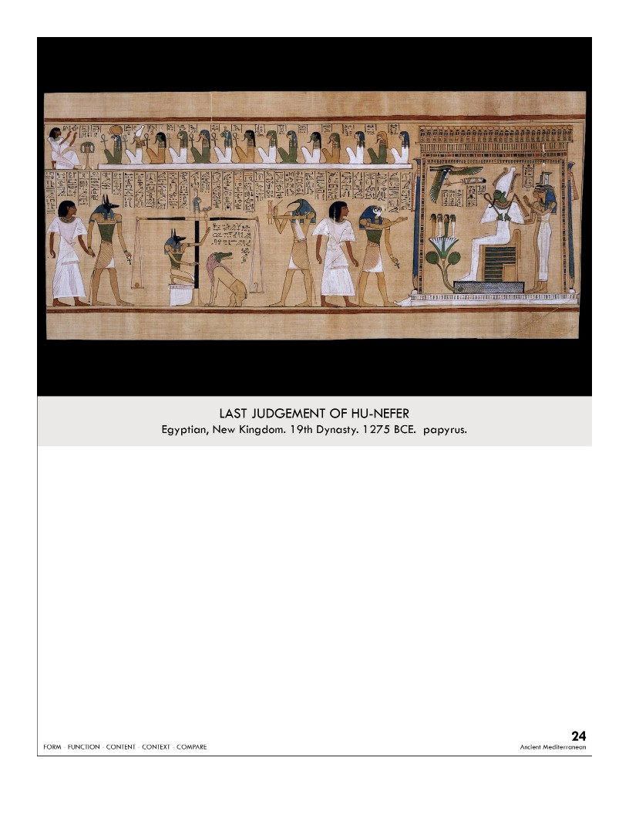

| **Form:**  Papyrus scroll with hieroglyphics and paintings  This scroll is 18.5 inches long  **Function:**  To prove Hunefer, the white-robed priest depicted in the above scenes, had lived an ethical life and deserved to enter the afterlife.  **Content:**  Anubis the jackal headed god— Scales the weigh the scales  Crocodile monster to eat his heart (omit) — Kneeling in front of the gods  Lead by horis to receive eternal life**,** Thath — records  **Context:**  Persons ca a life force that continues to exist after you die( soul)  He was a royal scribe  Egyptian text with spells, prayers, and incantations that helped the dead in the afterlife.  Book of the Dead was part of "pyramid text" writing (instructions for afterlife.)  Pyramid Text preceded "coffin texts:" instructions written on coffins, and also writing on shrouds.  **Compare:**  **24**  Ancient Mediterranean |
| --- |

[Form, content, function, context notes sheet](https://aucaparthistory.files.wordpress.com/2016/09/form-content-function-context-notes-sheet.pdf)